**AREA OF CALCULATOR**

**SOLUTION:**

char resp;

do

{

Console.WriteLine("which shape do you want to calculate the area:");

Console.WriteLine("\n1) circle\n2) triangle\n3) rectangle\n4) square\n5) trapezoid");

Console.Write("\nenter your response through --- 1,2,3,4 and 5 --- :");

int res = int.Parse(Console.ReadLine());

switch (res)

{

case 1:

Console.WriteLine("\n\t------- AREA OF CIRCLE -------- \n");

double r,aoc,r2;

const double pi = 3.14;

Console.Write("enter radius of circle: ");

r = double.Parse(Console.ReadLine());

Console.WriteLine("pie = {0}",pi );

r2 = Math.Pow(r, 2);

aoc = pi * r2;

Console.WriteLine("\n AREA OF CIRCLE = {0}",aoc);

break;

case 2:

Console.WriteLine("\n\t------- AREA OF TRIANGLE -------- \n");

double based , height;

Console.Write("enter base of triangle: ");

based = double.Parse(Console.ReadLine());

Console.Write("enter height of triangle: ");

height = double.Parse(Console.ReadLine());

double aot = ( based * height)/2;

Console.WriteLine("\n AREA OF TRIANGLE = {0}", aot);

break;

case 3:

Console.WriteLine("\n\t------- AREA OF RECTANGLE -------- \n");

double based1, height1;

Console.Write("enter base of rectangle: ");

based1 = double.Parse(Console.ReadLine());

Console.Write("enter height of rectangle: ");

height1 = double.Parse(Console.ReadLine());

double aor = based1 * height1;

Console.WriteLine("\n AREA OF RECTANGLE = {0}", aor);

break;

case 4:

Console.WriteLine("\n\t------- AREA OF SQUARE -------- \n");

double side;

Console.Write("enter side of square: ");

side = double.Parse(Console.ReadLine());

double aos = side*side ;

Console.WriteLine("\n AREA OF RECTANGLE = {0}", aos);

break;

case 5:

Console.WriteLine("\n\t------- AREA OF TRAPEZOID -------- \n");

double based1_t, based2_t, height_t;

Console.Write("enter base of one side of trapezoid: ");

based1_t = double.Parse(Console.ReadLine());

Console.Write("enter base of another side of trapezoid: ");

based2_t = double.Parse(Console.ReadLine());

Console.Write("enter height of triangle: ");

height_t = double.Parse(Console.ReadLine());

double aotr = ( (based1_t + based2_t) * height_t)/2;

Console.WriteLine("\n AREA OF TRIANGLE = {0}", aotr);

break;

default:

Console.WriteLine("\n\t INVALID SHAPE---");

break;

}

Console.Write("\ndo you calculate area of another shape(y/n): ");

resp = char.Parse(Console.ReadLine());

} while (resp == 'y');

**OUTPUT:**

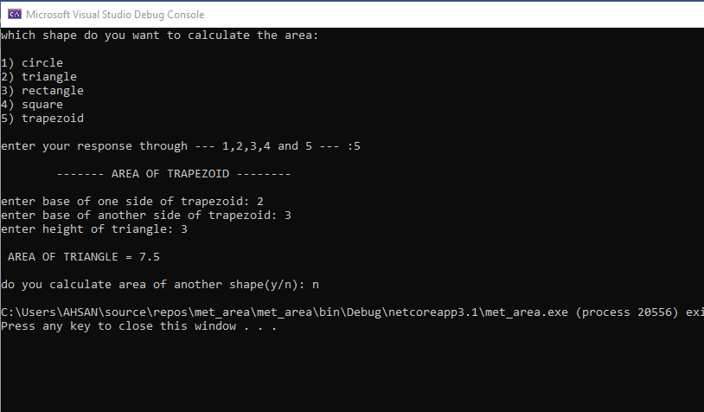

**AREA OF CALCULATOR USING METHOD**

**SOLUTION:**

using System;

namespace met_area

{

class Program

{

static void AOC()

{

Console.WriteLine("\n\t------- AREA OF CIRCLE -------- \n");

double r, aoc, r2;

const double pi = 3.14;

Console.Write("enter radius of circle: ");

r = double.Parse(Console.ReadLine());

Console.WriteLine("pie = {0}", pi);

r2 = Math.Pow(r, 2);

aoc = pi * r2;

Console.WriteLine("\n AREA OF CIRCLE = {0}", aoc);

}

static void AOT()

{

Console.WriteLine("\n\t------- AREA OF TRIANGLE -------- \n");

double based, height;

Console.Write("enter base of triangle: ");

based = double.Parse(Console.ReadLine());

Console.Write("enter height of triangle: ");

height = double.Parse(Console.ReadLine());

double aot = (based * height) / 2;

Console.WriteLine("\n AREA OF TRIANGLE = {0}", aot);

}

static void AOR()

{

Console.WriteLine("\n\t------- AREA OF RECTANGLE -------- \n");

double based1, height1;

Console.Write("enter base of rectangle: ");

based1 = double.Parse(Console.ReadLine());

Console.Write("enter height of rectangle: ");

height1 = double.Parse(Console.ReadLine());

double aor = based1 * height1;

Console.WriteLine("\n AREA OF RECTANGLE = {0}", aor);

}

static void AOS()

{

Console.WriteLine("\n\t------- AREA OF SQUARE -------- \n");

double side;

Console.Write("enter side of square: ");

side = double.Parse(Console.ReadLine());

double aos = side * side;

Console.WriteLine("\n AREA OF RECTANGLE = {0}", aos);

}

static void AOTR()

{

Console.WriteLine("\n\t------- AREA OF TRAPEZOID -------- \n");

double based1_t, based2_t, height_t;

Console.Write("enter base of one side of trapezoid: ");

based1_t = double.Parse(Console.ReadLine());

Console.Write("enter base of another side of trapezoid: ");

based2_t = double.Parse(Console.ReadLine());

Console.Write("enter height of triangle: ");

height_t = double.Parse(Console.ReadLine());

double aotr = ((based1_t + based2_t) * height_t) / 2;

Console.WriteLine("\n AREA OF TRIANGLE = {0}", aotr);

}

static void Main(string[] args)

{

char resp;

do

{

Console.WriteLine("which shape do you want to calculate the area:");

Console.WriteLine("\n1) circle\n2) triangle\n3) rectangle\n4) square\n5) trapezoid");

Console.Write("\nenter your response through --- 1,2,3,4 and 5 --- :");

int res = int.Parse(Console.ReadLine());

switch (res)

{

case 1:

AOC();

break;

case 2:

AOT();

break;

case 3:

AOR();

break;

case 4:

AOS();

break;

case 5:

AOTR();

break;

default:

Console.WriteLine("\n\t INVALID SHAPE---");

break;

}

Console.Write("\ndo you calculate area of another shape(y/n): ");

resp = char.Parse(Console.ReadLine());

} while (resp == 'y');

}

}

}

**OUTPUT:**



**MY WEEKLY EXPENSE**

**SOLUTION:** int a = 0;

Console.Write("Enter no of DAys: ");

int n = int.Parse(Console.ReadLine());

double[] petrol = new double[n];

double[] lunch = new double[n];

double[] pc = new double[n];

for (int i = 0; i < n; i++)

{

if (i==a)

{

Console.WriteLine();

}

Console.Write("Enter Expense OF DIESEL OF DAY {0} = ",i+1);

petrol[i] = double.Parse(Console.ReadLine());

Console.Write("Enter Expense OF Lunch OF DAY {0} = ",i+1);

lunch[i] = double.Parse(Console.ReadLine());

Console.Write("Enter Expense OF photo copy OF DAY {0} = ",i+1);

pc[i] = double.Parse(Console.ReadLine());

a += 1;

}

Console.WriteLine("\n");

Console.WriteLine("MAXIMUM , MINIMUM AND AVERAGE EXPENSE OF PETROL:\n");

maximum(petrol,n);

minimum(petrol,n);

average(petrol,n);

Console.WriteLine("\nMAXIMUM , MINIMUM AND AVERAGE EXPENSE OF LUNCH:\n");

maximum(lunch,n);

minimum(lunch,n);

average(lunch,n);

Console.WriteLine("\nMAXIMUM , MINIMUM AND AVERAGE EXPENSE OF PHOTO_COPY:\n");

maximum(pc,n);

minimum(pc,n);

average(pc,n);

}

public static void average(double[] ahsan,int b)

{

double avg = 0;

for (int i = 0; i < b; i++)

{

avg += ahsan[i];

}

double average = avg / b;

Console.WriteLine("Average = {0}",average);

}

public static void minimum(double[] bilal, int b)

{

double min=0;

for (int i = 0; i < b; i++)

{

if (i==0)

{

min = bilal[i];

}

if (bilal[i] < min)

{

min = bilal[i];

}

}

Console.WriteLine("MINIMUM EXPENSE = {0}", min);

}

public static void maximum(double[] mohsin, int b)

{

double max = 0;

for (int i = 0; i < b; i++)

{

if (i == 0)

{

max = mohsin[i];

}

if (mohsin[i] > max)

{

max = mohsin[i];

}

}

Console.WriteLine("MAXIMUM EXPENSE = {0}", max);

}

**OUTPUT:**